GGames

My first web shop made with PHP MVC

Table of contents

1. Introduction 2

2. Job description 2

3. Database structure 2

4. Mock-ups 4

5. User Story’s 8

6. Structure 9

6.1 Welcome Page 10

6.2 Shop Page 10

6.3 Login / Logout / Register 10

6.4 Account Page 10

6.4.1 All about the account 10

6.4.2 Credit 10

6.4.3 All purchased games 10

7. Versions 10

8. Conclusion 10

9. List of figures 11

# Introduction

On the internet there exist a bunch of web shops to buy stuff like shoes, food, clothes, and video games. I was always asking me how to create a web shop as good as amazon. So, when I was learning PHP, I found out how to create a web shop like that.

# Job description

This project didn’t come from my boss or something else. I give myself this job because I wanted to know how this work.

My own description:

Developing a website where you can buy games (not for real money). It should be a shop like amazon, steam, or blizzard.

# Database structure

Below you can find the database structure used for my web shop:

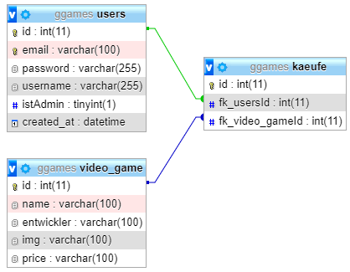

Figure 1: Database structure

Down below you see all the exact values which have been used to create the database:



Figure 2: Values for database structure

# Mock-ups

When you are developing a software or a website then you need to know how the site would look like. Down below you see some self-made mock-ups created with [draw.io](https://app.diagrams.net/):

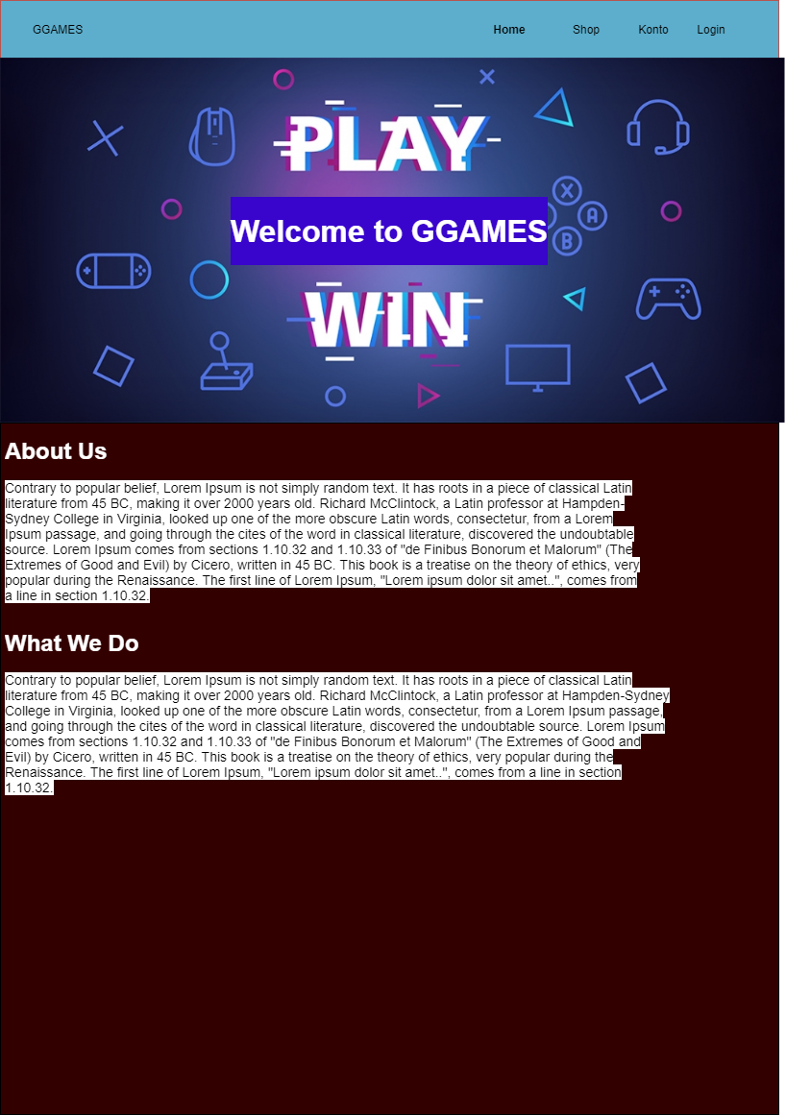

Figure 3: Mock-up for welcome page

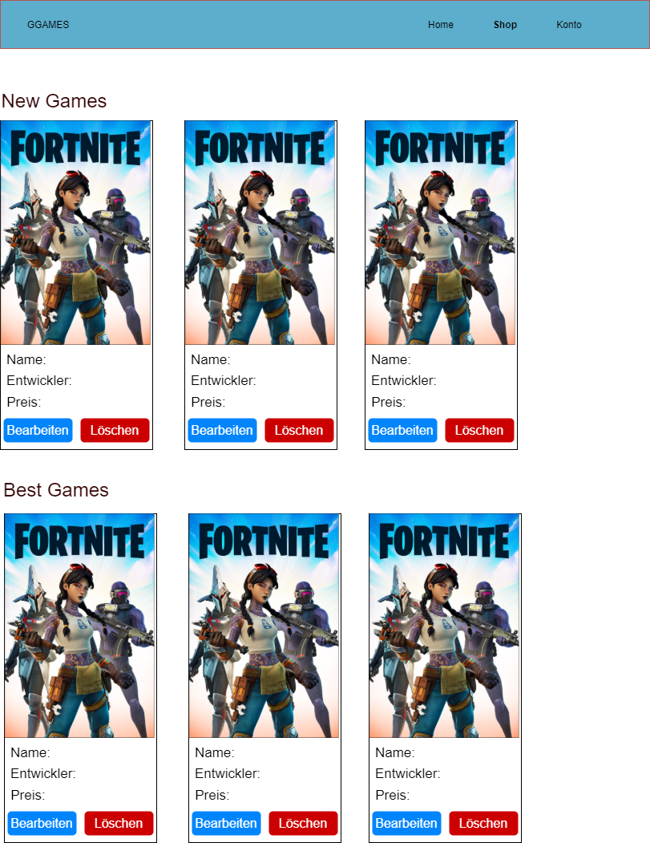

Figure 4: Mock-up for shop page

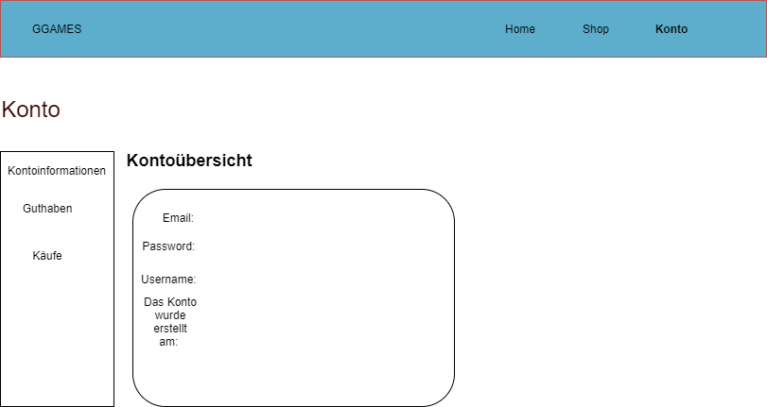

Figure 5: Mock-up for account page

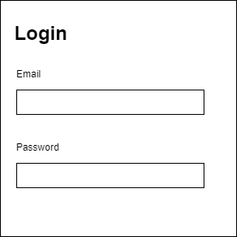

Figure 6: Mock-up for login page

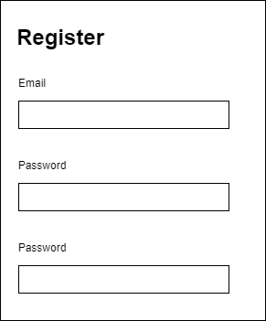

Figure 7: Mock-up for register

# User Story’s

Here you can find all the user stories for this project:

|  |  |
| --- | --- |
| User Story 1 |  |
| Title | Add games |
| Story | As a user with admin rites, I can add games to the website, so every costumer can see them and buy. |
| Effort | 30min |
| Priority | 1 |

|  |  |
| --- | --- |
| User Story 2 |  |
| Title | Edit games |
| Story | As a user with admin rites, I can edit games on the website, so every costumer can see the current information’s about the game. |
| Effort | 30min |
| Priority | 1 |

|  |  |
| --- | --- |
| User Story 3 |  |
| Title | Remove games |
| Story | As a user with admin rites, I can remove games from the website, so anyone can see the game anymore on the website. |
| Effort | 30min |
| Priority | 1 |

|  |  |
| --- | --- |
| User Story 4 |  |
| Title | Buy games |
| Story | As a user with admin rites or nor rites I can buy every game from the website, so that I can purchase them. |
| Effort | 8h |
| Priority | 1 |

|  |  |
| --- | --- |
| User Story 5 |  |
| Title | Login |
| Story | As an unlogged user I can log me in, so that I can purchase games. |
| Effort | 25min |
| Priority | 1 |

|  |  |
| --- | --- |
| User Story 6 |  |
| Title | Register |
| Story | As an unlogged an unregistered user I can register me, so that I can log me in. |
| Effort | 25min |
| Priority | 1 |

|  |  |
| --- | --- |
| User Story 7 |  |
| Title | Buy logout |
| Story | As a logged in user, I can log me out, so that I can secure my account. |
| Effort | 10min |
| Priority | 1 |

# Structure

This website contains following sites:

* Welcome Page
* Shop Page
* Login / Logout / Register
* Account Page

## Welcome Page

On that page the user has the possibility to see some information about the site and about GGames itself. You can see this page even when you’re not logged in. Everyone can see it.

## Shop Page

In the shop page the user can see and only buy games when he is logged in. Otherwise, he would be directed after clicking to buy to the login page. But you can see all the games when you’re not logged in.

## Login / Logout / Register

At those pages the user has the possibility to login, logout, or register. In the login page the user only can login when he has an account. If he doesn’t, he must create an account on the register page. To logout the user must already be logged in, otherwise it’s not possible.

## Account Page

On the account page the user has several options to use:

* See all about the account itself
* See his credit
* See all his games he bought

### All about the account

As the title says the user has there the opportunity to see all his information’s. He sees his email, the hashed password (not the real password), the username and when the account has been created.

### Credit

On this page the user can only see his credit. Not more.

### All purchased games

At this page the user can find all his games which he bought.

# Versions

All the versions of the web shop you can find on this [GitHub](https://github.com/Oli7000/GGames) repository.

# Conclusion

I’m very happy that I could finally finish this project. Of course, that the web page will sometimes get a little upgrade, but I don’t think that I will change a lot of stuff on that page.

While working on that project I had a lot of problems waiting Infront of me. Before I am starting the project, I developed the database structure. First, I thought that this would be the easiest and fastest part. But I wasn’t. Because when I was developing the database structure so fast, I didn’t check if everything would be ok. But this I found out later when I was programming the web page. At first everything was easy. I could add games, change them, or delete easily. But when I tried (when I was logged in) to buy a game, it didn’t work as I imagined it should. It took me so long to fix this problem. But after long research I could find the problem while I was asking a college for help. When I finally fixed the problem, it worked as it should. You can’t imagine how glad I was for fixing this problem which turned my head every single time when I wanted to restart the project because of this. And yes, I restarted more than once. I restarted it about more than two or three times. Anyway, you can see every version on my repository on GitHub.

When I would start another project like that I would plan more. Because in this project I didn’t plan anything, and it cost me a lot of useful time.

Anyway, I’m very glad for finishing this project and I would be ready to start a new one.

# List of figures

Figure 1: Database structure 2

Figure 2: Values for database structure 3

Figure 3: Mock-up for welcome page 5

Figure 4: Mock-up for shop page 6

Figure 5: Mock-up for account page 7

Figure 6: Mock-up for login page 7

Figure 7: Mock-up for register 8